Course Project: Two person chat room

Here is the scratch.

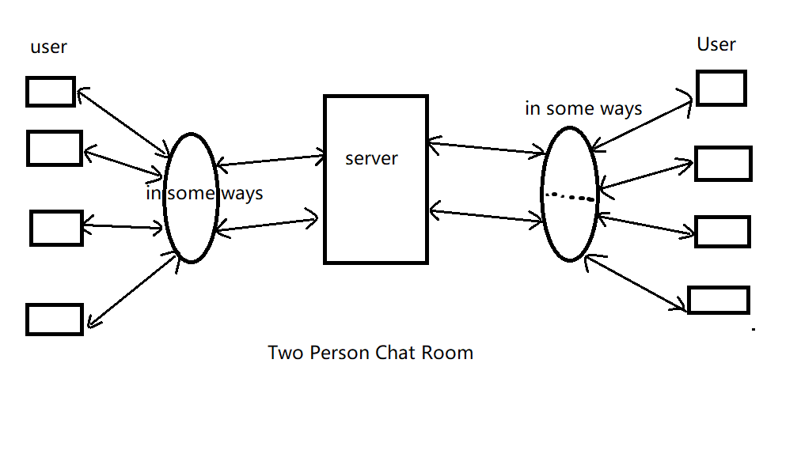

Here is the design of this Two-person Chat Room.

1. From the perspective of application layer, Apps runs on the User’s device. Here are the functionalities of the app:
2. Creat or enter the virtual room and talk with someone else by voice or text;
3. Get the information of all rooms. Private(password required) or public(available to anyone)?

May use the “http” protocol to request and receive web page from the server.

1. Quit, delete the room.
2. Here are the functionalities of the programs that runs on server:
3. Respond to the user’s request and send web page to the User. (http protocol).
4. Distribute the resources to the User. Connect the Users with each other who are in the same room.
5. May need some protocols designed for the message transferred between the users and server.
6. From the perspective of Transport layer, I may use the TCP protocol to transfer data between the server and the users.
7. From the perspective of network layer, I need to use IP protocol to find each end systems.
8. From the link layer, I may need various link-layer protocols to connect the different nodes along the route from user to server.